Office Space Rental App
React JSX — Hands-on Lab Report

Objectives
- Define JSX
- Explain about ECMAScript
- Explain React.createElement()
- Explain how to create React nodes with JSX
- Define how to render JSX to DOM
- Explain how to use JavaScript expressions in JSX
- Explain how to use inline CSS in JSX

Prerequisites
- Node.js
- NPM
- Visual Studio Code
Estimated time to complete this lab: 60 minutes.

1. What is JSX?
JSX (JavaScript XML) is a syntax extension for JavaScript used with React. It lets developers write markup that looks like HTML directly inside JavaScript code, instead of calling document.createElement() or React.createElement() by hand. JSX is not valid JavaScript on its own — it is compiled by a tool such as Babel into plain JavaScript function calls (React.createElement()) before it runs in the browser. JSX makes component structure easier to read and write, allows embedding of JavaScript expressions using curly braces {}, and supports attributes, children, comments, and conditional rendering, all while ultimately producing regular React elements.

2. What is ECMAScript?
ECMAScript (ES) is the standardized scripting language specification on which JavaScript is based. It is maintained by ECMA International (Technical Committee 39, or TC39) and defines the core syntax, types, statements, operators, and built-in objects that every JavaScript engine must implement. Different versions are commonly referred to as ES5, ES6/ES2015, ES2016, and so on, with a new version released every year. Modern React development relies heavily on ECMAScript features introduced in ES6 and later, such as classes, arrow functions, template literals, destructuring, the spread/rest operators, let/const, and modules (import/export). Tools like Babel transpile newer ECMAScript syntax (and JSX) into a form that is compatible with older browsers.

3. What is React.createElement()?
React.createElement() is the core function React uses internally to describe what should appear on the screen. It takes three arguments: the type of element (an HTML tag name string such as 'div', or a component), a props object (attributes/properties, or null if there are none), and any children. It returns a plain JavaScript object called a React element, which is a lightweight description of a DOM node — not an actual DOM node itself. React later reads this object (via ReactDOM) and creates the real DOM elements. Every piece of JSX is converted into one or more React.createElement() calls behind the scenes by the Babel compiler.
// JSX written by the developer
const element = <h1 className="title">Hello, Office!</h1>;

// What Babel compiles it into
const element = React.createElement(
"h1",
{ className: "title" },
"Hello, Office!"
);

4. Creating React Nodes with JSX
Because JSX compiles down to React.createElement() calls, any JSX expression produces a React element (a node in the virtual DOM tree). Nodes can be nested to build a full tree of elements, exactly the way nested HTML tags describe a page structure. A JSX expression must return a single root node, so multiple sibling elements are usually wrapped in a parent element or a React Fragment (<>...</>).
function OfficeHeading() {
return (
<h1 className="page-title">Office Space Rental App</h1>
);
}

5. Rendering JSX to the DOM
Once a JSX tree has been converted into React elements, it needs to be attached to an actual HTML page. This is done using the ReactDOM library. ReactDOM.createRoot() takes a real DOM node (usually a <div id="root"> in index.html) and creates a React root for it; calling root.render() with a JSX element then instructs React to build the corresponding DOM nodes and insert them into that container. React compares (diffs) the new element tree against what is currently on screen and updates only the parts of the real DOM that changed, which is what makes React efficient for updates.
import React from 'react';
import ReactDOM from 'react-dom/client';
import App from './App';

const root = ReactDOM.createRoot(document.getElementById('root'));
root.render(<App />);

6. Using JavaScript Expressions in JSX
Any valid JavaScript expression can be embedded inside JSX by wrapping it in curly braces {}. This allows variables, function calls, ternary conditions, arithmetic, and object/array values to be inserted directly into the markup. Only expressions are allowed inside {} — statements such as if blocks or for loops cannot be written directly, but their results (through helper functions, ternaries, or array methods like .map()) can be.
const office = { name: 'DBS Office Space', address: 'Hyderabad', rent: 50000 };

function OfficeDetails() {
return (
<div>
<h2>Office Details</h2>
<p>Name : {office.name}</p>
<p>Address : {office.address}</p>
<p>Rent : ₹{office.rent}</p>
</div>
);
}

7. Using Inline CSS in JSX
Inline styles in JSX are provided as a JavaScript object rather than a CSS string. The style attribute takes an object whose keys are camelCase versions of CSS property names (for example backgroundColor instead of background-color) and whose values are strings or numbers. Because it is a JavaScript object, its color value can be computed dynamically — for example, changing the text color of the rent amount based on whether the rent is above or below a threshold.
function RentDisplay({ rent }) {
const rentStyle = {
color: rent < 60000 ? 'red' : 'green',
fontWeight: 'bold',
};

return <p>Rent : ₹<span style={rentStyle}>{rent}</span></p>;
}

8. Implementation — Office Space Rental App
The lab requires creating a React application named "officespacerentalapp" that uses JSX to create elements and attributes, and renders them to the DOM. The implementation below covers: (a) a heading element, (b) an image attribute for the office space photo, (c) an object holding one office's Name, Address, and Rent, and (d) an array of office objects rendered with .map(), with the rent color conditionally set to red (below ₹60,000) or green (₹60,000 and above).
// App.js
import React from 'react';
import officeImage from './assets/office.jpg';

// Single office object (Objective: create an object of office details)
const mainOffice = {
name: 'DBS Office Space',
address: 'Hyderabad',
rent: 50000,
};

// List of office objects (Objective: create a list of objects)
const officeList = [
{ name: 'Tech Park', address: 'Bangalore', rent: 55000 },
{ name: 'Cyber Towers', address: 'Hyderabad', rent: 75000 },
{ name: 'Business Hub', address: 'Chennai', rent: 45000 },
{ name: 'Corporate Plaza', address: 'Mumbai', rent: 90000 },
];

function App() {
return (
<div className="app">
{/* Heading element */}
<h1>Office Space Rental App</h1>

{/* Image attribute for office space */}
<h2>Office Space Image</h2>
<img src={officeImage} alt="Office Space" width="400" />

{/* Object rendered with JS expressions */}
<h2>Office Details</h2>
<p>Name : {mainOffice.name}</p>
<p>Address : {mainOffice.address}</p>
<p>
Rent :
<span style={{ color: mainOffice.rent < 60000 ? 'red' : 'green' }}>
₹{mainOffice.rent}
</span>
</p>

{/* List rendered by looping through array with .map() */}
<h2>Available Office Spaces</h2>
{officeList.map((office, index) => (
<div key={index} style={{ border: '1px solid #000', margin: '10px', padding: '10px' }}>
<h3>{office.name}</h3>
<p>Address : {office.address}</p>
<p>
Rent :
<span style={{ color: office.rent < 60000 ? 'red' : 'green' }}>
₹{office.rent}
</span>
</p>
</div>
))}
</div>
);
}

export default App;

How the CSS rule is applied
Each office card computes its rent color inline using a ternary expression inside the style object: office.rent < 60000 ? 'red' : 'green'. This satisfies the requirement that rent below ₹60,000 is shown in red and rent of ₹60,000 or above is shown in green, as seen in the output — for example DBS Office Space (₹50,000), Tech Park (₹55,000), and Business Hub (₹45,000) appear in red, while Cyber Towers (₹75,000) and Corporate Plaza (₹90,000) appear in green.

9. Output
The rendered application, showing the heading, office image, office details object, and the list of available office spaces looped through with conditional rent coloring:
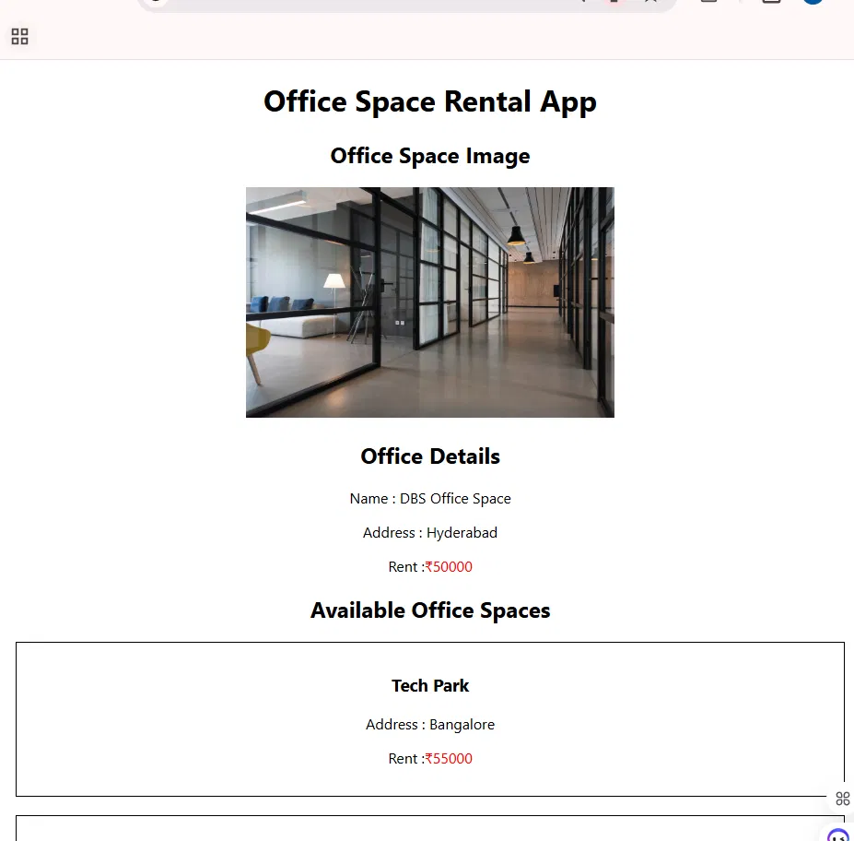
Figure 1: Top of the page — heading, office image, office details, and the first item in the available office spaces list.
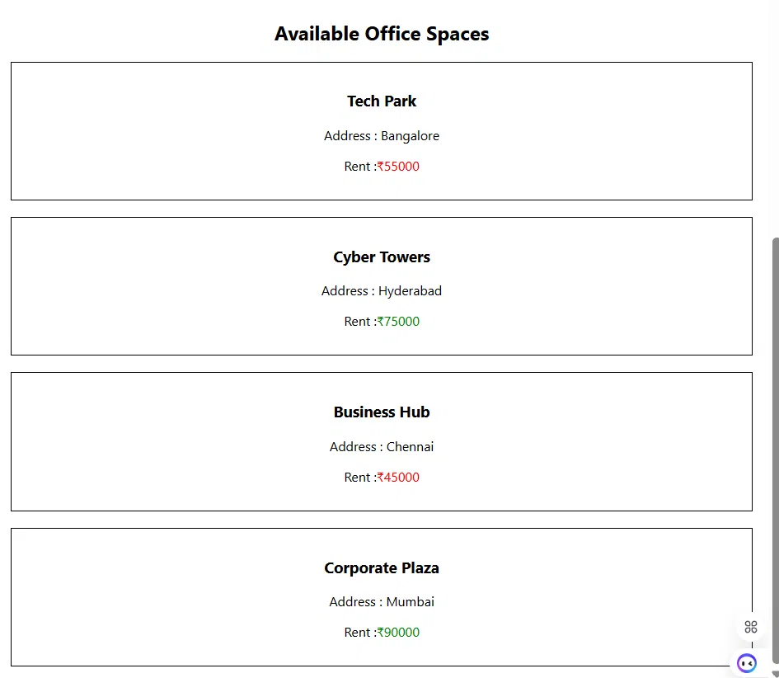
Figure 2: Full list of available office spaces, with rent shown in red (below ₹60,000) for Tech Park and Business Hub, and in green (₹60,000 and above) for Cyber Towers and Corporate Plaza.

Conclusion
This lab demonstrated how JSX, a syntax extension built on modern ECMAScript features, allows React elements to be authored in an HTML-like style while compiling down to React.createElement() calls. Using ReactDOM, these JSX-based elements were rendered to the DOM inside the Office Space Rental App. JavaScript expressions embedded with curly braces were used to display data from an office object and to loop through a list of office objects, while inline CSS style objects were used to conditionally color the rent value red or green based on the ₹60,000 threshold.

